Smart charger cabinets
MQTT protocol proposal
v0.7

Version Record:
Serial number | Protocol number | Version number | Modify the content | Modifier | Update time
1 | V101 | V101
2 | V101 | V101 | Revise:  - Added"Events notification" topic key: value in Event  - Blue mark used
3 | V101 | V101 | Revise:  1.Revise MQTT's BMS information content based on BMS information
4 | V101 | V101 | Revise:  1.Sample error change
5 | V101 | V101 | Revise:  1.Add soc in “notification”
6 | V101 | V102 | Revise:  1. Add threshold configuration topic publication and threshold configuration subscription response
7 | V101 | V102 | 1. Add some events to the notification topic
8 | V101 | V103 | 1. Add QR code address configuration

Emphasize:
- MQTT protocol support version
V3.1/V3.1.1
- QoS class：2

Table of contents

Workflow representation 4
1.1. Sequence diagram for the process of saving cabinets data to our database 4
1.2. Sequence diagram for the battery charging operation 6
Topics description 7
2.1. Cabinet information 7
2.2. Open Slot 10
2.3. Events notification 11
2.4. Alerts 12
2.6. Thresholds 12
2.7. ThresholdsResponse 13
2.8. Order information 14
2.9. Order information confirmation 15
2.10. Open slot request 15
Extra information 16
3.1. Slot description 16
Questions to the supplier 16

Workflow representation

1.1. Sequence diagram for the process of saving cabinets data to our database

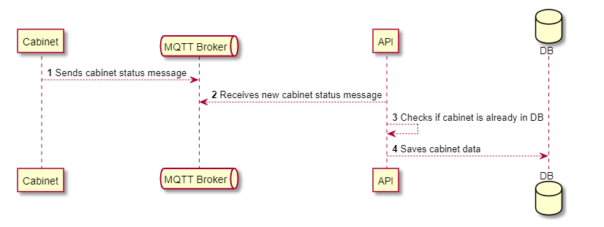

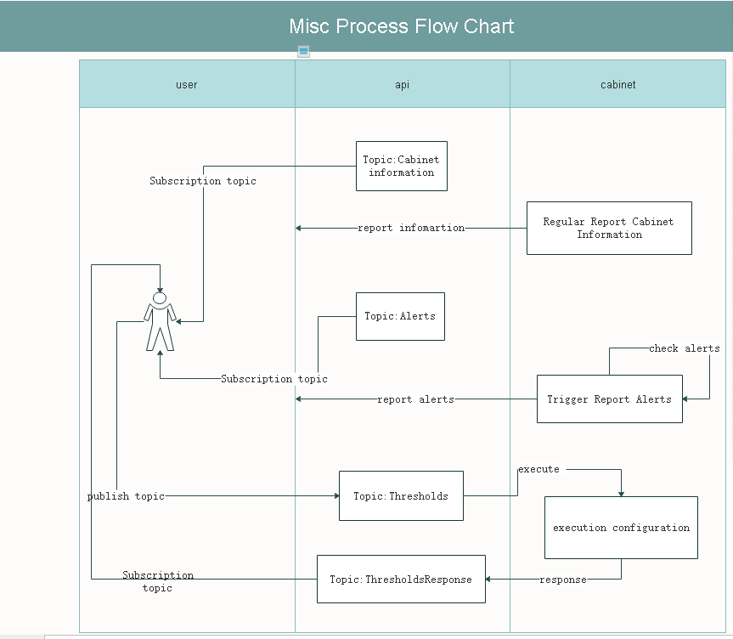

1.2. Sequence diagram for the battery charging operation

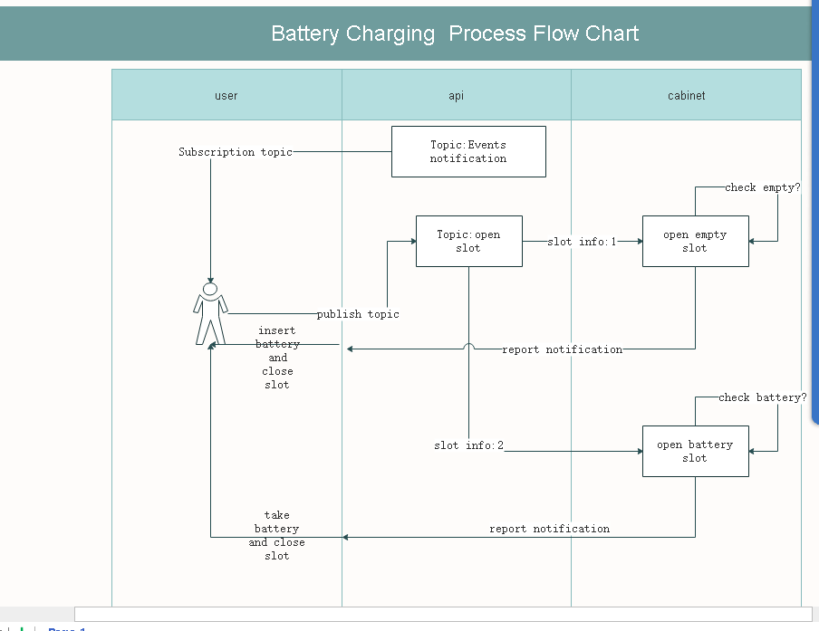

1.3 Order Information Flowchart
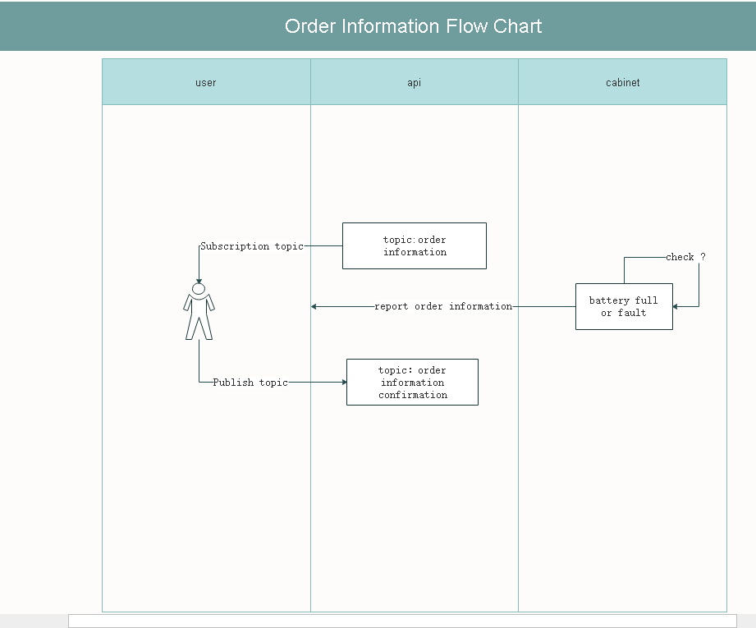

Topics description

2.1. Cabinet information
Topic where the cabinet will send the complete status of the cabinet and the batteries inside of it every 30s and after a new battery is inserted or removed from one of the slots.

topic: /stations/info/{cabinet_mac_addr}

Field name | Type | Description
mac_addr | String | cabinet’s mac address
device_id | String | Device ID
ctr_pro | String | Ctr Board Protocol
ctr_softver | String | Ctr Board Software version
ctr_warning | BOOL | true:cabinet exist warning false:No warning
env_temperature | Integer | Environment temperature
empty_slots | Integer | Total empty slots in cabinet
total_slots | Integer | Total slots in cabinet
slots | List<Slot> | Information about individual slots (3.1. Slot description)
timestamp | DateTime | timestamp of message creation

Example:
{
"mac_addr": "00-88-14-4D-4C-FB",
"device_id": "2600401516050001",
"ctr_pro": "V101",
"ctr_softver": "V101",
"ctr_warning": false,
"env_temperature": 24,
"empty_slots": 2,
"total_slots": 8,
"slots": [
{ //This slot has the battery charging and the relay is on
"sub_pro": "V101",
"sub_softver": "V101",
"id": 1,
"slot_temp"：34,
"slot_type"：1, //battery slot
"door_status": 0, //close
"sub_Exit_Err": false,
"order_num": "ORD202307111850123456",
"charging_volt": 120.1,
"charging_curr":2.3,
"charge_status":1, //charging
"start_time":1690192606,
"end_time":1690192696
"deposit_time":0
},
{ //This slot is empty and the relay is disconnected
"sub_pro": "V101",
"sub_softver": "V101",
"id": 2,
"slot_temp"：33,
"slot_type"：0, //empty slot
"door_status": 0, //close
"sub_Exit_Err": false,
"order_num": "",
"charging_volt": 0.0,
"charging_curr":0.0,
"charge_status":0, //uncharge, idle
"start_time":0,
"end_time":0
"deposit_time":0
},
{ //This slot has the battery, but charge end, and the relay is disconnected
"sub_pro": "V101",
"sub_softver": "V101",
"id": 3,
"slot_temp"：32,
"slot_type"：1, //battery slot
"door_status": 0, //close
"sub_Exit_Err": false,
"order_num": "",
"charging_volt": 0.0,
"charging_curr":0.0,
"charge_status":2, //charge end
"start_time":1690192606,
"end_time":1690192906
"deposit_time":1690202606

}
{ //This slot is error and the relay is disconnected
"sub_pro": "V101",
"sub_softver": "V101",
"id": 4,
"slot_temp"：32,
"slot_type"：0, //empty slot
"door_status": 0, //close
"sub_Exit_Err": true, //Error
"order_number": "",
"charging_volt": 0.0,
"charging_curr":0.0,
"charge_status":0, //uncharge, idle
"start_time":0,
"end_time":0
"deposit_time":0
}
],
"timestamp": "2021-08-03 17:04:54.123Z"
}

2.2. Open Slot
Topic where the cabinet will receive the command to open specific slots.

topic: /stations/open_slot/{cabinet_mac_addr}

Field name | Type | Description
slot_id | Integer | Slot identification
slot_info | integer | 0x01:open empty slot door. Server  0x02:open battery slot door. Server  0x03:start charging, relay is on Cabinet/ Server  0x04:stop charging, relay is disconnected Cabinet/ Server  0x05:set battery slot to empty slot Server
order_number | String | business order number
timestamp | DateTime | timestamp of message creation

Note:
Example:
{
"slot_id": 1,
"slot_info": 1,
"order_number": "ORD202307111945345678",
"timestamp": "2021-08-03 17:04:54.123Z"
}

2.3. Events notification
Topic where the cabinet will send notifications after every action it takes (for example: closing or opening a slot).

topic: /stations/notifications/{cabinet_mac_addr}

Field name | Type | Description
slot_id | Integer | Slot identification
order_number | String | business order number
event | String | name of the event. (open_slot, close_slot,open_slot_busy,open_slot_success,open_slot_sub_no_execution,door_err,sub_execution_timeout,sub_offline,open_empty_slot_bat_online,open_bat_slot_bat_offline,insert_faulty_battery,close_empty_no_save_bat,opt_success,close_slot_timeout,waiting_open_full_timeout, ota_upgrading，ota_sub_upgrading,  )
timestamp | DateTime | timestamp of message creation

Example:
{
"slot_id": 1,
"order_number": "ORD202307111945345678",
"event": "open_slot",
"timestamp": "2021-08-03 17:04:54.123Z"
}

2.4. Alerts
Topic where the cabinet will send alerts if it identifies any software or hardware alerts or errors.

topic: /stations/alerts/{cabinet_mac_addr}

Field name | Type | Description
slot_id | Integer | Slot identification (null if the alert isn’t for a specific slot)
type | String | message type (alert, error)
message | String | message describing the problem  (Error:)(cabinet_alert:"Lightning warning",” Smoke alarm  ”,"Subsequent updates for the remaining labels";"Internal battery failure"  charger_type_err:"Charger temperature is too high","Subsequent updates for the remaining labels")
timestamp | DateTime | timestamp of message creation

Example:
{
"slot_id": 1,
"type": "Error",
"message": "Charging failure",
"timestamp": "2021-08-03 17:04:54.123Z"
}

Thresholds
The topic can be used for subscription thresholds and update thresholds. It is mainly used for debugging and initial production configuration. It is not recommended to publish the topic during use, because the service will restart after receiving the topic

topic: /stations/thresholds/{cabinet_mac_addr}

Field name | Type | Description
info_up_period | Integer | cabinet information reporting cycle（unit:sec）
max_charge_current | Integer | Maximum charging current value  (unit:mA)
alert_up_period | Integer | alert reporting cycle (unit:sec)
slot_over_temp | Integer | when this value is reached, the slot will be powered off
over_temp | Integer | cabinet over temperature threshold, when this value is reached, the entire cabinet will be powered off
dev_id | String | Device Unique Identification
ad_switch | boolean | true:turn on screen false:turn off screen
open_times | String | Card Swipe Auto-Open Time (hh:MM) — 24-Hour Format default:00:00

Example:
{
"info_up_period": 60,
"max_charge_current"：20000,
"alert_up_period":300,
"slot_over_temp":80,
"over_temp":70,
"dev_id":"DEV888676767",
“ad_switch”:true,
“open_times”:”06:42”
}

ThresholdsResponse
It is mainly used to confirm whether the threshold is successfully set to the cabinet

topic: /stations/thresholds_response/{cabinet_mac_addr}

Field name | Type | Description
info_up_period | BOOL | true:success false:failed
max_charge_current | Bool | true:success false:failed
alert_up_period | Bool | true:success false:failed
slot_over_temp | Bool | true:success false:failed
over_temp | Bool | true:success false:failed
dev_id | Bool | true:success false:failed
ad_switch | bool | true:success false:failed
open_times | bool | true:success false:failed

Example:
{
"info_up_period":true,
"max_charge_current"：true,
"alert_up_period":true,
"slot_over_temp":true,
"over_temp":true,
"dev_id":true,
“ad_switch”:true,
“open_times”:true
}

Order information
The terminal machine should promptly upload a record of the end of charging order for a certain slot and wait for the backend to respond to the charging order with that order number.
topic: /stations/order_info/{cabinet_mac_addr}

Field name | Type | Description
mac | string | cabinet’s mac address
slot_id | int | slot identification
order_num | string | business order number
start_time | int | local time when the slot is successfully opened
end_time | int | local time when charging ends due to full or failed charging
charge_time | int | charging duration, counting from opening the slot(unit:minutes)
charge_status | Int | 0:open empty slot 1:charging 2:finished 3:open full slot
deposit_time | Int | charge over start counting,end in open full slot

Order information confirmation
The server must reply to the terminal's charging end record upload

topic: /stations/order_info_confirm/{cabinet_mac_addr}

Field name | Type | Description
mac | string | cabinet’s mac address
slot_id | int | slot identification
order_num | string | business order number

Extra information

3.1. Slot description

Field name | Type | Description
sub_pro | String | Sub Board Protocol
sub_softver | String | Sub Board Software version
id | Integer | Slot identification
sub_Exit_Err | BOOL | true:sub exist warning  false:No warning
slot_type | Integer | 0:emtpy slot; 1:battery slot;
door_status | Integer | 0：close; 1：open
slot_temp | Integer | Environmental temperature of a single slot
order_num | String | business order number
charging_volt | double | Charging voltage(unit:0.1V)
charging_curr | double | Charging current(unit:0.1A)
charge_status | Integer | 0:uncharge 1:charging 2:charge end
order_num | String | business order number
start_time | Integer | local time when the slot is successfully opened
end_time | Integer | local time when charging ends due to full or failed charging
deposit_time | Integer | charge over start counting,end in open full slot

Questions to the supplier

- Do the cabinets have a unique ID other than the Mac Address?

